UNIT-2
LOCALIZATION
The important function of a sensor network is to collect and forward data to destination. It is very important to know about the location of collected data. This kind of information can be obtained using Localization technique in wireless sensor networks (WSNs). Localization is the process of finding the position of nodes as data and information are useless if the nodes have no idea of their geographical positions. WSNs are closely associated with the physical phenomena in their surroundings. The gathered information needs to be associated with the location of the sensor nodes to provide an accurate view of the observed sensor ﬁeld.
Moreover, WSNs may be used for tracking certain objects for monitoring applications, which also necessitates location information of the sensor nodes being incorporated into the tracking algorithms. Localization techniques makes the deployment of WSNs economical. monitoring. Most of the devices or nodes in wireless sensor network are made up of off-the-shelf materials and deployed in the area of surveillance and monitoring. The responsibility of each sensor node is to identify the changes in its particular region or area. The changes are like movement of animals, increase or decrease in temperature or rainfall and these changes are periodically reported to the aggregation point or the central server.
Wireless sensor networks are fundamentally intended to provide information about the spatial-temporal characteristics of the observed physical world. Each individual sensor provides <S,T,M > , where S is the space, T is the Time and M is the measurements.
The location information of nodes in the network is required for number of reasons:-
1.To provide location stamp
2.To locate and track point objects
3.To monitor the spatial evolution of a diffuse phenomenon over time
4.To determine the quality of coverage
5. To achieve load balancing
6.To form clusters
7. To facilitate routing
8.To provide efficient spatial querying
Localization techniques makes the deployment of WSNs economical. monitoring. Most of the devices or nodes in wireless sensor network are made up of off-the-shelf materials and deployed in the area of surveillance and monitoring. The responsibility of each sensor node is to identify the changes in its particular region or area. The changes are like movement of animals, increase or decrease in temperature or rainfall and these changes are periodically reported to the aggregation point or the central server.
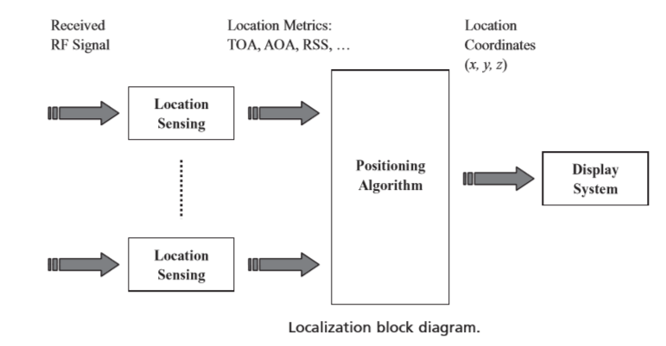
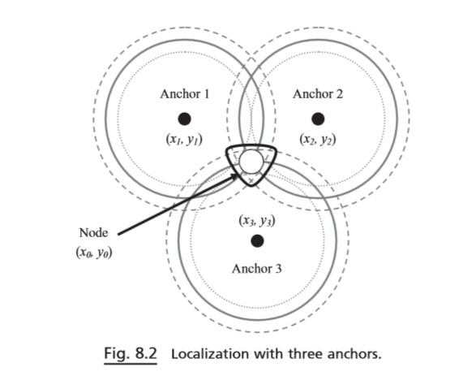
APPLICATION REQUIREMENTS FOR LOCALIZATIONS
The field of networked sensor systems encompasses a very broad array of applications, with a broad range of requirements. Often different application requirements can motivate very different systems.
PASSIVE HABITAT MONITORING
Scientists in numerous disciplines are interested in methods for tracking the movements and population counts of animals in their natural habitat. While there are various techniques currently employed (e.g. rings on birds' claws, "drop buckets" for small animals on the ground), these techniques do not scale well in terms of the time required of experimenters. One of the open challenges in this field is to develop an automated system that can build a record of the passage and habits of a particular species of animal, without disturbing it in its natural habitat.
SMART ENVIRONMENTS
Smart environments are a second class of applications where location awareness is a key component. Smart environments are deeply instrumented systems with very demanding localization requirements. These systems need localization for two different purposes. First, rapid installation and self-configuration of a set of infrastructure "beacons" is required to reduce installation cost and increase flexibility. Second, very fine-grained localization and tracking of the system components is required during normal system operation.
KEY ISSUES
Localization is quite a broad problem domain and the component issues and techniques can be classified on the basis of a number of key questions:-
- What to Localize:- This refers to identifying which nodes have a priori known locations(called reference nodes) and which nodes do not(unknown nodes) .
- When to Localize:- in static environment localization is a one-shot process but in other cases we may refresh localization , as objects and network nodes move around over time. The time scale vary considerably from minutes,days or even months.
- How well to localize:- depending on localization technique to provide absolute(x, y, z)coordinates, or relative coordinates or symbolic locations. The technique must provide the desired type and accuracy of localization, taking into account the available resources.
- Where to localize:- The actual location computation can be performed at several different points in the network. At a central location, in a distributed iterative manner within reference nodes.
- How to localize:-Different signal measurements can be used as inputs to different localization techniques. The signals used can vary from narrowband radio signal strength readings or packet loss statistics, UWB RF signals, acoustic/ultrasound signals,infrared. The signals may be emitted by reference nodes, unknown nodes or both.
LOCALIZATION APPROACHES
There are two approaches to localization :-
- Coarse –grained localization using minimal information:- these typically use a small set of discrete measurements, such as the information used to compute location. Minimal information could include binary proximity( can two nodes hear each other), near-far information(which of two nodes is closer to a given third node), or cardinal information(is one node in the east, west,south sector of the other given node).Minimal information techniques are simpler to implement, lower resource consumption, and equipment costs and provide lower accuracy than detailed information.
- Fine grained localization using detailed information:-These are typically based on measurements such as RF power, signal waveform, time stamps that are real values or discrete with large no of quantization levels. These include techniques based on radio signal strength, timing information, and angulation.

- Coarse-grained localization using minimal information / Range free localization
Range-free localization protocols, on the other hand, do not required distance estimation. While the existence of a beacon node may still be required, the location of other nodes is estimated through range-free techniques.
- Binary Proximity:-The most basic location technique is that of binary proximity-involving a simple decision of whether two nodes are within reception range of each other. A set of reference nodes are placed in the environment in some non-overlapping manner. Either the reference nodes periodically emit beacons, or the unknown node transmits a beacon when it need to be localized. If reference nodes emit beacons, these include their location IDs.the unknown node must then determine which node it is closest to , and this provides a coarse-grained localization. An excellent example of proximity detection as a means of localization is the active badge system meant for indoor office environment. This system consists of small badge cards(about 5 sq cm) sending unique beacon signals once every 15 sec with a 6 meter range. The active badges , with wired sensor network provides coverage throughout a building, provide room level location resolution.
- Consider a two dimensional scenario Let there be n reference nodes detected within the proximity of the unknown node, with the location of the ith such reference denoted (x_{i},y_{i}) . Then , in this technique ,the location of the unknown node(x_{u},y_{u}) is determined as
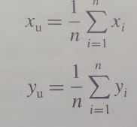
3.Convex position Estimation(CPE)/ Centralised localization:- The lack of ranging information poses additional challenges for localization since a limited amount of information is available. However, even without accurate distance measurements, the connectivity information between a node and its neighbors can still be exploited to constrain the location of the node as described in the following example.
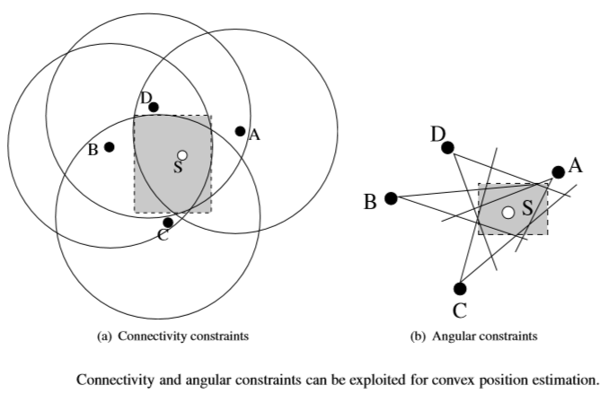
Consider the case shown in above Figure (a), where node S is within the communication range of nodes A, B, C, and D. If the location of node B and its transmission range R are known, then node S can deduce that it is located in a circle centered around node B with radius R. Any additional neighbor with location information such as nodes A, C, and D further constrains the possible location of node S.As a result ,the connectivity of a node provides approximity constraint parameter, which can be utilized to solve an optimization problem and estimate the location of the node.
If AoA information is available, angular constraints can also be used for estimation as shown in Figure (b). By combining the connectivity constraints from multiple neighbors of a node, the central controller creates a bounding box in which the node should reside. As shown in Figure (a) and Figure(b), the bounding box is a rectangle which includes the possible locations of the node subject to the connectivity or angular constraints, i.e. ,feasible position sets. Then, the center of the bounding box is selected as the location of the node. The bounding box is generally generated from the connectivity information from beacon nodes. However, in case of a lack of sufﬁcient beacon nodes, the unknown nodes are also included in the connectivity information to further constrain the location of the node. This is similar to the iterative multilateration technique used in AHLoS.
3.Approximate point in triangle(APIT):- The APIT protocol relies on a network that consists of wireless sensor nodes as well as beacon nodes with known locations. RSS information from multiple nodes is used to estimate the relative locations of these nodes. Here multiple beacon nodes are distributed which have known locations and periodically broadcast beacons to the rest of the nodes in the fields. Each sensor node can receive beacons form a subset of these beacon nodes and localize itself.
Referring to Figure (a), let us assume that node S receives beacon signals from beacon nodes A, B, C, D, and E. Since node S is aware of the positions of the beacon nodes, it can form triangles using any three of these nodes as shown in Figure (b). If the node can determine whether it is inside or outside of these triangles, the intersections of these triangles can be used to deﬁne a small area in which the node should reside. Consequently, using multiple beacon signals, a node can localize itself up to a certain accuracy
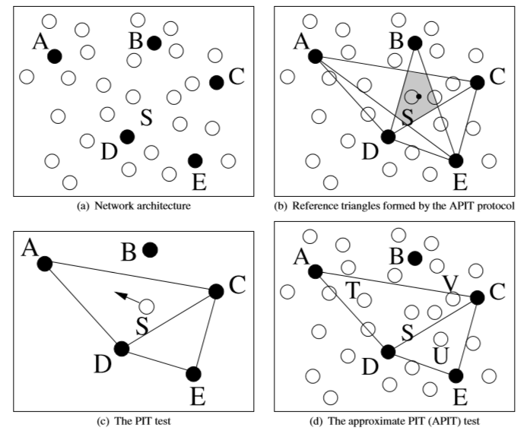
Based on the architecture APIT protocol consists of 4 phases:-
1. Beacon exchange
2. PIT testing
3. APIT aggregation
4. Center of gravity calculation(COG)
1.Beacon exchange:- when a node receive beacon from beacon nodes, a node populate a table with the location of each node and the value of RSS . The information is then broadcast to each neighbor nodes . This information is used which to estimate whether a node is inside a triangle formed by three beacon nodes in the PIT testing phase.
2. PIT testing: The PIT test is performed to determine whether a node is inside a triangle formed by three beacon nodes. Ideally, this can be performed by moving the node along any axis as shown in Figure (c). The node is outside the triangle if there exists a direction such that whenever a node is moved in this direction, its distances to the three vertexes of the triangle increase or decrease simultaneously. Otherwise, the node is inside the triangle.
As shown in Figure (c), when node S is moved in the direction shown by the arrow, its distance to nodes C, D, and E increases. Hence, it can be concluded that node S is outside the triangle CDE. However, since its distance to node A decreases, but increases for nodes C and D, it is inside the triangle ACD. This is referred to as the point-in-triangulation (PIT) test. However, in WSNs, since a node cannot be moved, an approximate PIT (APIT) test is performed instead.
The APIT test is illustrated in Figure (d), which exploits the high density of WSNs. Instead of moving a node, each node checks the connectivity information of its neighbors. For a given triangle ACD, a node S ﬁrst determines the neighbor nodes (T, U, V in Figure (d)) that also receive beacons from these beacon nodes. Then, node S checks whether ith as a neighbor that is farther from the three beacon nodes simultaneously. To this end, the RSS values are used. Although the RSS values are not used to calculate the exact distance, the difference between the RSS values of two nodes is used to determine whether a node is farther or closer to the beacon node. If a node ﬁnds such a neighbor, then it determines that it is outside the particular triangle. The APIT test is performed for each triangle and then APIT aggregation is performed to constrain the location of the node.
APIT aggregation: The APIT test determines the triangles in which node S resides. As shown in Figure (b), the intersection of these triangles deﬁnes the region where the node should reside. Following the APIT test, node S calculates the maximum overlapping area to estimate its location through APIT aggregation.
COG calculation: The last phase of the APIT protocol is the COG calculation. In this phase, the node determines its location as the COG of the overlap area found in the previous phase. This location is shown as a dot in Figure (b).
2.Fine grained Localization /Range based Localization:- The range-based localization protocols necessitate efficient ranging techniques through which the distance or angle to a particular node can be found. Each ranging technique may require special hardware support, which limits the applicability of these techniques. Moreover, the accuracy of distance or angle estimation varies for each technique. Consequently, the choice of the ranging technique is based on the requirements of the application as well as the hardware capabilities. These include triangulation, using distance estimates, pattern matching and sequence decoding.
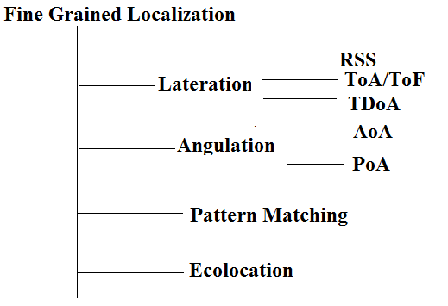
RSS(Received Signal Strength)
Ranging through RSS is accomplished by sensing the received signal and measuring the total received power, which can provide a distance estimate between the target object and the location sensor. each sensor node is equipped with a radio and in most cases is able to report the received signal strength of an incoming packet, this technique has minimal hardware requirements. The main idea is to estimate the distance of a transmitter to a receiver using the following information:
• The power of the received signal;
• Knowledge of the transmitted power;
• The path-loss model.
In this scheme, the beacon nodes broadcast periodic beacon messages, which are used to estimate the distance to them. The power of the received signal is communicated by the transceiver circuitry through the RSSI(Received Signal Strength Indicator).The received signal strength from sensor node i at node j at time t is represented
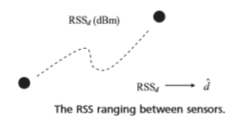
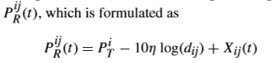
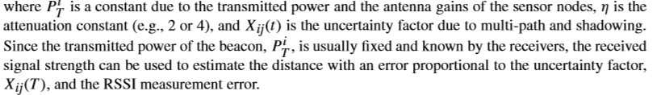
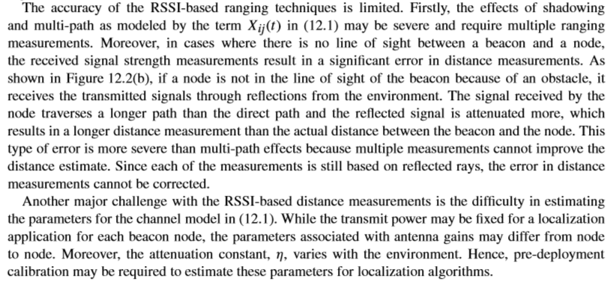

2.ToA/ToF(Time of arrival /Time of flight)
Time-of-Arrival(ToA)techniques rely on accurate measurements of transmit and receive times of signals between two nodes. These measurements are used to estimate the distance based on the propagation time and the speed of the signal. Since timing information is used for distance measurements, synchronization is essential for these techniques. It exploits the relationship between distance and transmission time when the propagation speed is known. Assuming both sender and receiver know the time when a transmission. E.g. a short ultra sound pulse starts, the ToA of this transmission at the receiver can be used to compute propagation time and thus distance. It can return any measurement pulse in a deterministic time.
Based on the measurement type, two types of ToA measurements can be performed:
• Active: The receiver transmits a ranging packet, which is immediately responded to by a transmitter. The round-trip time is used to estimate the distance between the nodes. • Passive: In this case, the transmitter and receiver measurements are made separately. Accordingly, a transmitter sends a beacon signal, which is used by the receiver to estimate the delay between the two nodes. However, for this technique, the time of signal transmission needs to be known. ToA techniques can be used to measure the propagation time between two nodes. The nodes then estimate the relative distance to a beacon by applying the measured propagation time to a complex distance formula. ToA techniques require very accurate hardware to measure the actual received time of the beacon signals. Any small error in time measurement can result in large distance estimate errors because of the high propagation speed of RF signals in air. Therefore, ToA techniques are not practical for traditional WSNs. On the other hand, challenging environments such as under water and underground exhibit low propagation speeds because of the properties of the communication media. Therefore, ToA techniques may be more suitable for these environments.
3.TDoA(Time difference of Arrival)
To overcome the need for explicit synchronization, the Time Difference of Arrival (TDoA) method utilizes implicit synchronization by directly providing the start of transmission information to the receiver.TDoA technique uses the combination of ultrasound/acoustic and radio signals to estimate distances by determining the TDoA of these signals. The idea to simultaneously transmit both the radio and acoustic signals(audible or ultrasound) and measure the times T_{r} and T_{s} of the arrival of these signals respectively at the receiver. Since the speed of the radio signal is much larger than the speed of the acoustic signal, the distance is then simply estimated as
(T_{s} –T_{r}) x V_{s} , where Vs is the speed of the acoustic signal.
One minor limitation of acoustic ranging is that it generally requires the node to be in fairly close proximity of each other(within few meters) and preferably in LOS. There also some uncertainty in the calculation as speed of sound varies depending on many factors
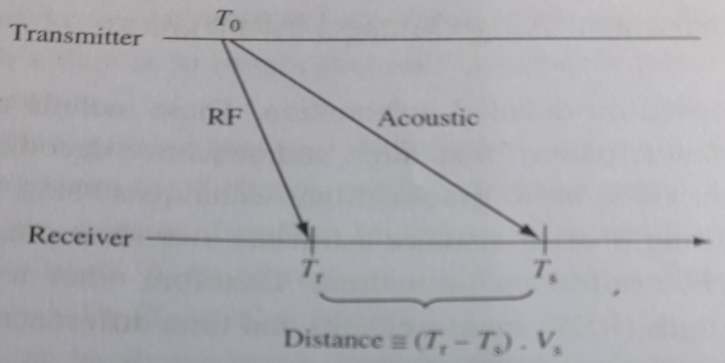
Such as altitude, humidity, and air temperature . Acoustic signals also show multi-path propagation effects that may impact the accuracy of signal detection. TDoA ranging techniques can be very accurate in practical settings. It claimed that distance can be estimated to within a few centimeters for node separations under 3 meters.
4.AoA(Angle of Arrival)
In addition to signal strength and timing , the direction of received signal can also exploited for localization. It uses angular estimates instead of distance estimates. AoA technique rely on directional antennas or special multiple antenna configurations to estimate the AoA of the received signal from beacon nodes.
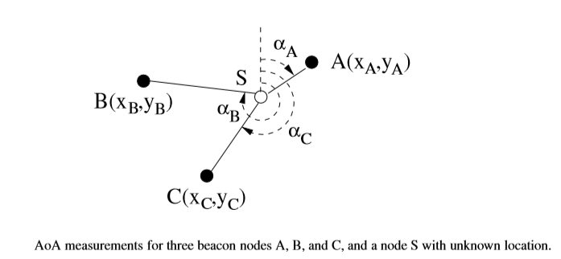
AoA techniques provide high localization accuracy depending on the measurement accuracy. However, higher complexity antenna arrays are required for direction measurement, which increases the cost. Furthermore, antenna arrays require a certain spacing to provide spatial diversity and to accurately measure the AoA. Considering the size of typical sensor nodes, such a separation may not be feasible, which makes AoA techniques impractical for certain WSNs. Finally, AoA techniques also suffer from multi-path and scattering as well as NLoS conditions. Since the direction of arrival is used for localization, the error due to NLoS components of the received signal may be even more severe compared to that of RSSI- or TDoA-based techniques.
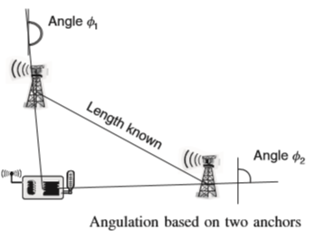
5.Pattern Matching(RADAR)
We can use a predetermined “map” of signal coverage in different locations of the environment, and use this map to determine where a particular node is located by performing pattern matching on its measurements. An example of this technique is RADAR. This technique requires the prior collection of empirical measurements of signal strength statistics from different reference transmitters at various locations. Once this information is collected, any node in the area is localized by comparing its measurements from these references to determine which location matches the received pattern best.
6.RF-Sequence decoding(Ecolocation)
The echolocation technique uses the relative ordering of received radio signal strengths for different references as the basis of localization. It works as follows:-
- The unknown node broadcasts a localization packets.
- Multiple references record their RSSI reading for this packet and report it to a common calculation node.
- The multiple RSSI readings are used to determine the ordered sequence of references from highest to lowest RSSI.
- The region is scanned for the location for which the correct ordering of references has the best match to the measured sequence. This is considered as the location of the unknown node.
NETWORK WIDE LOCALIZATION
In Node localization we are determining the location of a single unknown node given a number of near-by reference nodes.
In network localization several unknown nodes have to be localized with a few reference nodes. The node localization and ranging techniques often form a integral components of solution to network localization.
The performance of network localization depends on very much on the resources and information available within the network. For instance there may no reference nodes at all so only relative coordinates can be determined for the unknown nodes; if present the number/density of reference nodes may vary ;there may be just a single mobile reference. information about which nodes are within range of each other may be available or inter-node distance estimates may be available; inter node angle information may be available.
Some network localization approaches are centralized, in which all the available information about known nodes and the inter node distances or other inter node relationships are provided to a central node , where the solution is computed.
There are different types of network localization techniques exists they are :-
1.constraint based approaches
2.RSS based joint estimation
3.Iterative multi-lateration
4.collaborative multi-lateration
5.multihop distance-estimation approach
6.Refinement
1. Constraint-based approaches
Geometric constraints can often be expressed in the form of linear matrix inequalities and linear constraints. This applies radial constraint(two nodes are Within R of each other), annular constraint(a node is determined to be within ranges (R_{max},R_{min}) of another), angular constraint(a node within a particular angular sector of another) as well as convex constraints. Information about a set of reference nodes together with these constraints describes a feasible set of constraints for a semi-definite program.
When using bounded rectangles a distributed iterative solution can be used.
2.RSS-based joint estimation
If radio signal strengths can be measured between all pairs of nodes in the network that are within detection range, then a joint maximum likelihood estimation technique can be used to determine the location of unknown nodes in a network.
3.Iterative multilateration
This technique is applicable whenever inter-node distance information is available between all neighboring nodes. It applies the basic triangulation technique for node localization in an iterative manner to determine the locations of all nodes.one begin by determining the location of an unknown node that has the most reference nodes in its neighborhood.

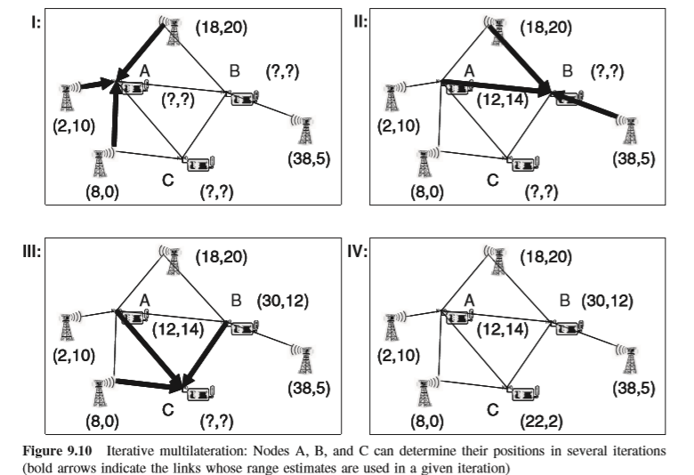
4.Collaborative Multi-lateration
One approach to tackle the deficiency of iterative multilateration with respect to nodes with insufficient reference neighbors is the collaborative multilateration approach.
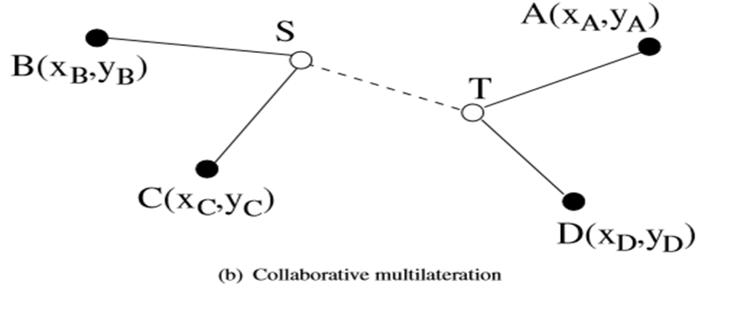
The key approach is to determine collaborative subgraphs within the network that contain reference and unknown nodes in a topology such that their positions and inter-node distance can be written as an over constrained set of quadratic equations with a unique solution for the location of unknown nodes . This technique is useful in portions of the network where the reference node density is low.
5.Multi-hop distance-estimation approach
An alternative approach to network localization utilizes estimates of distances to reference node that may be several hops away. These distance are propagated from reference nodes to unknown nodes using a basic distance-vector technique. There are 3 variants of this approach:-
- DV-hop:- in this approach node determines its distance from various reference nodes by multiplying the least number of hops to the reference nodes with an estimated average distance per hop.
- DV distance:-if inter-node distance estimates are directly available for each link in the graph , then the distance-vector algorithm is used to determine the distance corresponding to the shortest distance path between the unknown nodes and reference nodes.
- Euclidean propagation:- Geometric relations can be used in addition to distance estimates to determine more accurate estimates to reference nodes.
6.Refinement
Once a possible initial estimate for the location of unknown nodes has been determined through iterative mulilateration /collaborative multilateration, additional refinement steps can be applied. Each node continues to iterate, obtaining its neighbors location estimates and using them to calculate an updates become small and this refinement process can be stopped.
THEORETICAL ANALYSIS OF LOCALIZATION TECHNIQUES
1. Cramer-Rao lower bound
One theoretical tool of utility in analyzing limitations on the performance of localization techniques is the use of Cramer-Rao bound. The Cramer-Rao bound is a well known bound on the error variance of any unbiased estimator and is defined as the inverse of the Fisher information matrix (a measure of information content with respect to parameters. The CRB can be derived for different assumptions about localization technique (TOA, RSS, Proximity based).
The CRB has been used to investigate error performance of K-level quantized RSSI based localization.CRB analysis has been used to investigate the performance of network localization under different densities, and shown to give similar trends to the iterative /collaborative multilateration technique. The CRB based analysis suggests that localization accuracy improves with network density, with diminishing returns once each has about 6-8 neighbors on average.
2. Unique network localization
There is a strong connection between the problem of unique network localization and a mathematical subject known as rigidity theory.
Definition
Consider a sensor network with n nodes (m reference nodes and n-m unknown nodes) located in the 2D plane, with edges between neighboring nodes. Information is available about the exact location coordinates of the reference nodes, and the exact Euclidean distance between all neighboring nodes. This network is said to be uniquely localization if there exists only one possible assignment of (x,y) coordinates to all unknown nodes that is consistent with all the available information about distances and position.
The key result concerning the conditions for a network to be unique localizable is the following :
Theorem
A network N is uniquely localizable if and only if the weighted grounded graph G_{N} corresponding to its globally rigid.
There are two terms here that need to be explained weighted grounded graph and global rigidity. The weighted grounded Graph G_{N} is constructed from the graph described by network N by adding additional edges between all pairs of reference nodes, labeled with the distance between them.
TIME SYNCHRONIZATION
Given the need to coordinate the communication, computation, sensing and actuation of distributed nodes and the spatio-temporal nature of the monitored phenomena, it no surprise that an accurate and consistent sense of time is essential in sensor networks.
Distributed wireless sensor networks need time synchronization for a number of good reasons, some of which are :
1.For time-stamping measurements:- even the simplest data collection applications of sensor networks often require that sensor readings from different sensor nodes be provided with time stamps in addition to location information. This is particulary true whenever there may be a significant and unpredictable delay between when the measurement is taken at each source and when it is delivered to the sink/base station.
2.For in-network signal processing:- Time stamps are needed to determine which information from different sources can be fused/aggregated within the network.
3.For localization:-Time-of-Flight and TDoA layer multi-node cooperative communication techniques and in node localization require good time synchronization.
4.For cooperative communication:-Some physical layer multi-node cooperative communication techniques involve multiple transmitters transmitting in-phase signals to a given receiver. Such techniques have the potential to provide significant energy savings and robustness but require tight synchronization.
5.For medium-access:-TDMA-based medium –access schemes also require that nodes be synchronized so that they can be assigned distinct slots for collision –free communication.
6.For sleep scheduling:- one of the most significant sources of savings is turning the radios of sensor devices off when they are not active. However synchronization is needed to coordinate the sleep schedules of neighboring devices so that they can communicate with each other efficiently.
7.For coordinated actuation:- advanced applications in which the network includes distributed actuators in addition to sending require synchronization in order to coordinate the actuators through distributed control algorithm.
KEY ISSUES
The clock at each node consists of timer circuitry, often based on quartz crystal oscillators. The clock is incremented after each K ticks/interrupts of the timer. Practical timer circuits, particularly in low-end devices, are unstable and error prone. A model for clock non-ideality can derived using the following expressions.

Let f₀ = the ideal frequency
∆f = The frequency offset
d_{f} =The drift in the frequency
r_{f}(t)= additional random error process
then instantaneous oscillator frequency f_{i}(t) of oscillator i at time t can be modeled as follows:-
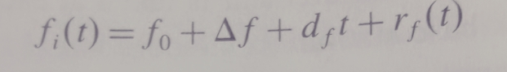
Then assuming t=0 as the initial reference time, the associated clock reads time C_{i} at time t , which is given as :
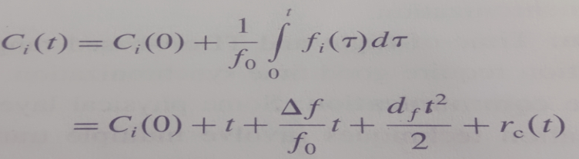
Where r_{c}(t) is the random clock error term corresponding to the error term Rf(t) in the expression for oscillator frequency. Frequency drift and the random error term may be neglected to derive a simpler linear model for clock non-ideality.
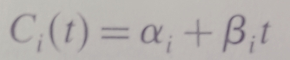
Where 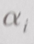 is the clock offset at the reference time t=0 and the clock drift (rate of change with respect to the ideal clock). The more stable and accurate the clock, the closer  is to 0, and the closer  is to 1. A clock is said to be fast if  is greater than 1, and slow otherwise.
Manufacture clocks are often specified with maximum drift rate parameter  such that
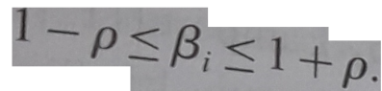 Motes typically sensor nodes, have  values on the order of 40 ppm(parts per million) which corresponds to a drift rate of  per second.
The simplest approach to time synchronization is a distributed system is through periodic broadcasts of a consistent global clock. In the US, the National institute for standards and technology runs the radio stations WWV, WWWVH, WWVB located at fort Collins,Colorado broadcasts timing signals on a 60 kHz carrier wave on a high power signal.
Traditional Approaches
Time synchronization is a long studied subject in distributed systems, and a no of well known algorithm have been developed for different conditions:-

1.Lamport algorithm
It provides a consistent ordering of all events in a distributed system, labeling each event x with a distinct time stamp L_{x} such that
a.Lx ≠L_{y} for all unique events x and y
b.if event x precedes event y with a node L_{x}<L_{y}
c.if x is the transmission of a message and y is its reception at another node Lx<Ly
These lamport time stamps do not provide true casuality.
2.Cristian’s algorithm
It is a fundamental technique for two node clock synchronization . A node A sends a request to node B and receives back the value of B’s clock T_{B}.node A records locally both the transmission time T₁ and reception time T₂ .
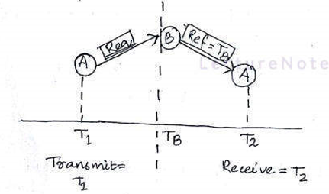
Here many sources of uncertainty and delay , which impacts its accuracy. In general message latency can be decomposed into 4 components:-
- Send time= any processing time + time taken to assemble and move the message to the link layer.
- Access time= which includes random delays while the message is buffered at the link layer due to contention and collisions.
- Propagation time= which is the time taken for point-to –point message travel.
- Receive time= which is the time taken to process the message and record its arrival.
Good estimates of the message latency as well as the processing latency within the reference node must be obtained for cristian’s algorithm.
FINE GRAINED CLOCK SYNCHRONIZATION
Several algorithm proposed for time synchronization in WSN. These all utilize time measurement based message exchange between nodes from time to time in order to synchronization the clocks on different nodes.
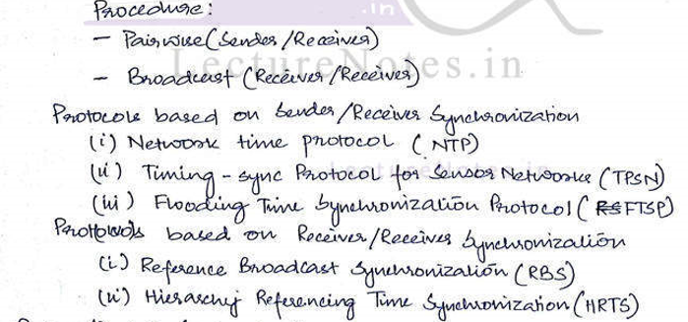
Receiver/Receiver Synchronization
1.Reference broadcast synchronization(RBS)
RBS aims to minimize the critical path in synchronization by eliminating the effect of the sender. This is accomplished by exploiting the broadcast nature of the wireless channel. Instead of synchronizing a sender with a receiver, RBS provides time synchronization among a set of receivers that are within the reference broadcast of a sender. Since the propagation times are negligible, once a packet is transmitted by a sender, it is received at its neighbors almost at the same instant. Consequently, the synchronization accuracy can be improved by synchronizing only the receivers.
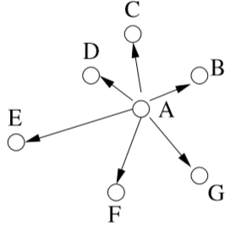
As shown in Figure above, the transmitter broadcasts m reference packets. Each of the receivers, which are within the broadcast range, records the time of arrival of the reference packets. Then, the receivers communicate with each other to determine the offsets. Let us compare this method to traditional synchronization, where the transmitter and each receiver are synchronized. As shown in Figure below(a),the critical path for traditional synchronization includes the sender side uncertainty as well.
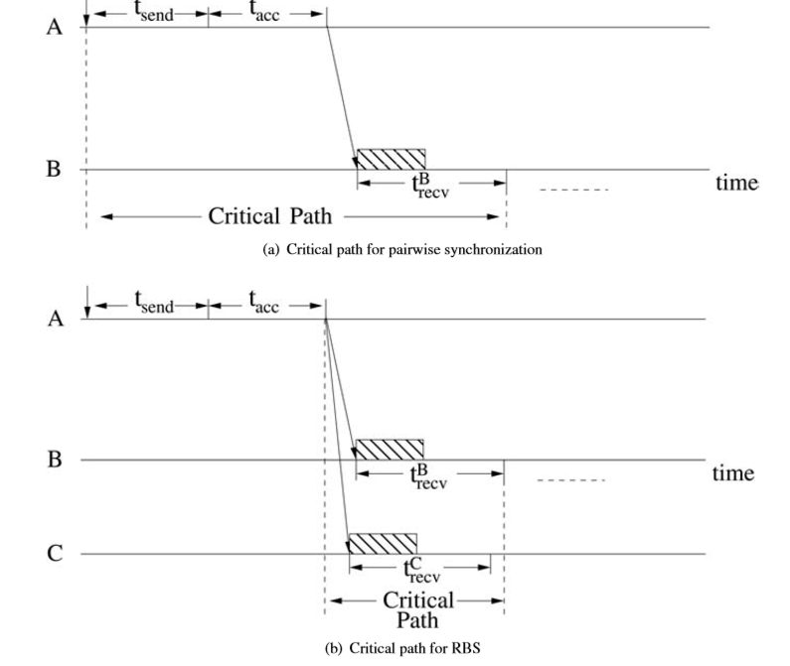
The sending delay as well as the access delay should be accurately estimated to improve the synchronization accuracy. Broadcast-based synchronization, however, does not involve the transmitter (node A) in the synchronization. Instead, only the receivers (nodes B, C, D, E, F, G) synchronize among themselves based on a broadcast message from the transmitter (node A). As shown in Figure above(b), this reduces the critical path. The only uncertainty in RBS is the time between when a packet is received and when it is time stamped. Considering the hardware capabilities of the sensor node, this delay can also be estimated up to a certain accuracy. The receiver–receiver synchronization method provides an efﬁcient way for each node to determine its clock offset relative to its neighbors. Following message exchanges from each neighbor, each node populates a table consisting of relative offsets with its neighbors. Consequently, RBS does not aim to correct the clocks of the nodes. Rather, whenever a packet with a timestamp is received, this timestamp is converted to the local clock using the relative offset information.
2. Hierarchy Reference time synchronization
The Hierarchy Referencing Time Synchronization (HRTS) protocol discussed below is a receiver/ receiver technique synchronizing all nodes in a broadcast domain and additionally constructing a synchronization tree to synchronize a whole network. The synchronization is triggered periodically by the root of the tree.
Synchronization in a broadcast domain .We explain the approach by an example, shown in Figure below.
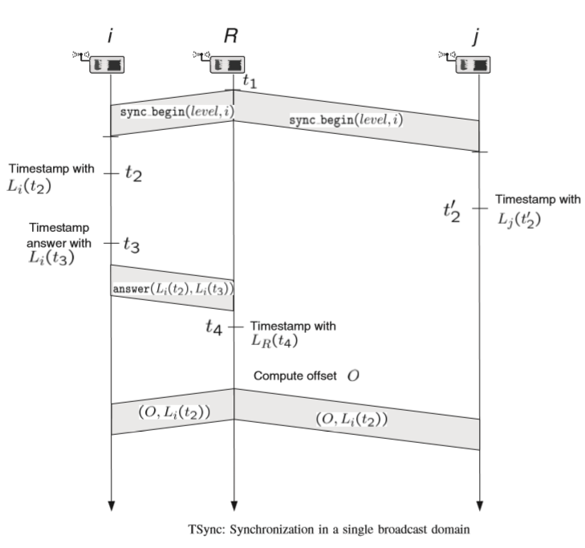
A dedicated node, called a root node or base station (node R in Figure above) triggers time synchronization at time t1 (corresponding to local time LR(t1)) by broadcasting a sync begin announcement packet. This packet includes two parameters, a level value (explained below) and the identiﬁcation of one of node R’s one-hop neighbors, say node i. The selected node i timestamps the received packet at time t2 with its local time Li(t₂). Another node j timestamps the same packet at time t’₂ with L_{j}(t’ ₂). Similar to RBS, t₂ and t₂ can differ slightly because of random receiver uncertainties. Since node i has found its identiﬁcation in the packet, it formats an answer packet and timestamps it for transmission at time t3 with its local time Li(t₃). Both timestamps Li(t₂) and Li(t₃) are included in the answer packet. The root node R receives the packet and timestamps it at time t₄ with LR(t₄). The root node R can now estimate the offset O_{R},_{i} between its own local clock and the local clock of node i in a similar fashion as in the pair-wise synchronization protocol of LTS and TPSN as
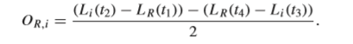
In the next step, the root node R broadcasts the values O and Li(t₂) to all nodes.
Sender/Receiver Synchronization
1.Network Time protocol(NTP)
In the Internet, the Network Time Protocol (NTP) is used to discipline the frequency of each host’s oscillator. Synchronization among hosts is accomplished through a hierarchical structure of time servers as shown in Figure below. In this hierarchical structure, the root is synchronized with UTC and at each level the time servers synchronize the clocks of their subnetwork peers. NTP relies on a two-way handshake between two nodes to estimate the delay between these nodes and calculate the relative offset accordingly.
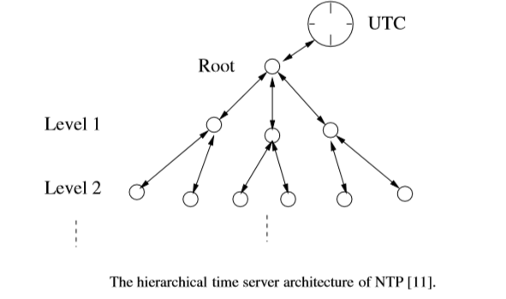
The accuracy of NTP synchronization is on the order of milliseconds. However, in NTP, it is assumed that the transmission delay between two host s is the same in both directions, which is reasonable for the Internet. While NTP provides robust time synchronization in a large-scale network, many characteristics of WSNs make this protocol unsuitable.
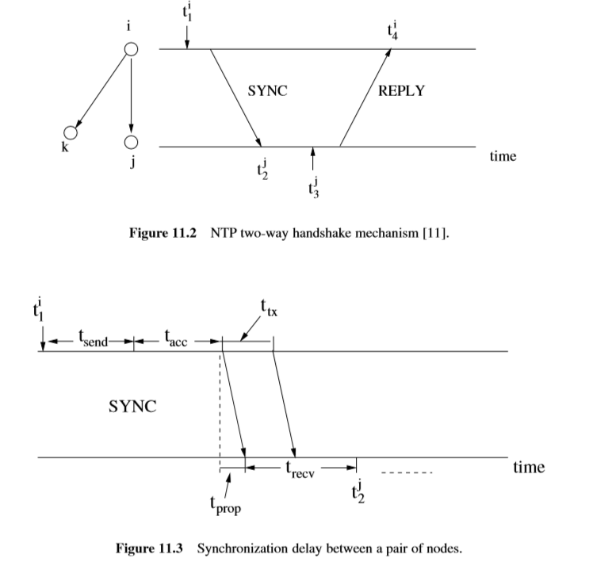
It may be useful to use NTP to discipline the oscillators of the sensor nodes, but connection to the time servers may not be possible because of frequent sensor node failures. In addition, synchronizing all sensor nodes into a single clock reference may be a problem due to interference from the environment and the large variations in delays between the different parts of the sensor ﬁeld. The interference can temporarily disjoint the sensor ﬁeld into multiple smaller ﬁelds leading to undisciplined clocks among these smaller ﬁelds. Moreover, NTP is computationally intensive and requires a precise time server to synchronize the nodes inthe network. Inaddition, itdoes not take intoaccount the energy consumption required for time synchronization. Although NTP is robust, it may suffer from large propagation delays when sending timing messages to the time servers. In addition, the nodes are synchronized in a hierarchical manner and some of the time servers in the middle of the hierarchy may fail causing unsynchronized nodes in the network. If these nodes fail, it is hard to reconﬁgure the network. NTP also assumes symmetric link delays between two nodes. Because of the wireless link errors and contention in the broadcast channel, this may not be true for WSNs. Consequently, the delay measurements may lead to inaccurate offset estimation.
2.Timing –sync protocol for sensor network(TPSN)
TPSN provides for classical sender-receiver synchronization. TPSN adopts a hierarchical structure is used to synchronize the whole WSN to a single timer sever.TPSN requires the root node to synchronize all or parts of the nodes in the sensor field. It has two phases:-
- The level discovery phase
- The synchronize phase
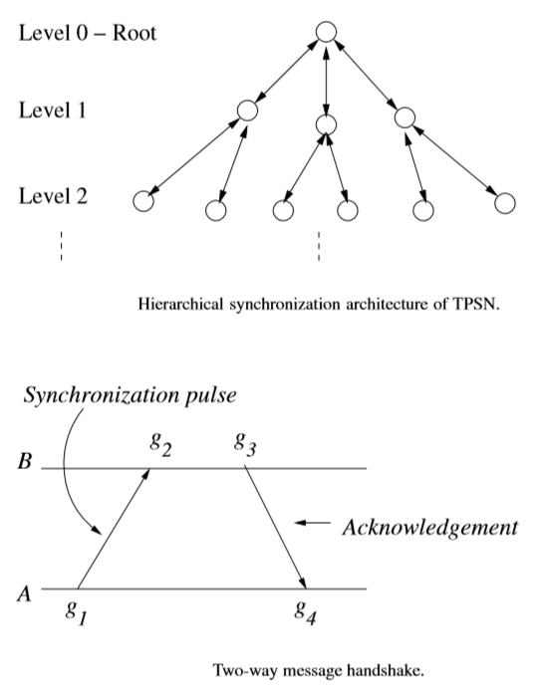
1.Level discovery phase
In the level discovery phase, the root node is assigned to level 0, and the nodes in the network are assigned levels in a hierarchy according to their distance to the root node as shown in Figure above. Firstly, the root node constructs the hierarchy by broadcasting a level_discovery packet. The ﬁrst level of the hierarchy is level 0, which is where the root node resides. The nodes that receive the level_discovery packet from the root node are the nodes that belong to level 1. Afterward, the nodes in level 1 broadcast their level_discovery packet, and neighbor nodes receiving the level_discovery packet for the ﬁrst time are labeled as level 2nodes. This process is repeated until all the nodes in the sensor ﬁeld have a level number.
2.synchronization phase
The root node sends a time_sync packet to initialize the time synchronization process. Then, the nodes in level 1 start synchronization with the root node by sending a synchronization_pulse to level 0 as shown in Figure above. To prevent collisions with multiple nodes, each node in level 1 waits for a random amount of time before transmitting the synchronization_pulse. The root node sends an acknowledgment back to the node to ﬁnalize synchronization. As a result, level 1 nodes are synchronized to the root. The synchronization_pulse from level1 also serves as a time_syncpacket to the neighbors of the level1 nodes,i.e.,level2 nodes. Upon hearing this packet from a node in level1,the nodes wait for a random amount of time that is long enough for the level 1 nodes to ﬁnish their synchronization. Then, they initialize the synchronization process by transmitting a synchronization_pulse as shown in Figure above. The level 1 node then sends an acknowledgment. The synchronization of the whole network is performed level by level in this way. TPSN is based on a sender–receiver synchronization model, where the receiver synchronizes with the local clock of the sender according to the two-way message handshake as shown in Figure.
3.Flooding time synchronization protocol(FTSP)
The FTSP aims to further reduce the following sources of uncertainties , which exists in both RBS and TPSN.
1.Interrupt handling time:- this the delay in waiting for the processor to complete its current instruction before transferring the message in parts to the radio.
2.Modulation/encoding time:- this the time taken by the radio to perform modulation and encoding at the transmitter and the corresponding demodulation and decoding at the receiver.
FTSP uses a broadcast from a single sender to synchronize multiple receivers. Unlike RBS the sender actually broadcasts a time measurement and the receivers do not exchange messages among themselves. Each broadcast provides a synchronization point ( a global –local time pair) to each receiver. FTSP has two main components:-
1.Multiple time measurements:- the sender takes several time stamp measurements during transmission , one at each byte boundary after a set of SYNC bytes used for byte alignment. These measurements are normalized by substracting an appropriate multiple of the byte transmission time and only the minimum of these multiple measurements is embedded into the message.
2.Flooded messaging :- to propagate the synchronization information , a flooding approach is used. First a single uniquely identifiable node in the network provides the global clock. The reception of each broadcast message allows a receiver to accumulate a reference synchronization point. When a receiver accumulates several reference points it becomes synchronized itself. Nodes can collect reference points either from the global reference node or from other nodes that are already synchronized.
Coarse-grained data Synchronization
An alternative to clock synchronization approaches that is suitable for data gathering applications. The approach is to collect and record latency measurements within each packet in a special residence time field as the packet propagates through the network. The estimate of delivery latency recorded in the packet is then used to provide a retroactive time stamp eventually at the base station when the packet arrives.
In this approach only the base station is required to have an accurate reference clock. Since the radio propagation delays are insignificant, what is measured at each hop is actually the time that the packet spends at each node-which can be of the order of milisecs due to queuing and processing delays.
****

